1) **How to compare two JSON have same properties without order?**

1. **Let obj1 = {name:” person 1”, age:5};**
2. **Let obj2 = {age:5, name:” person 1”};**

**Solution on below Image:**

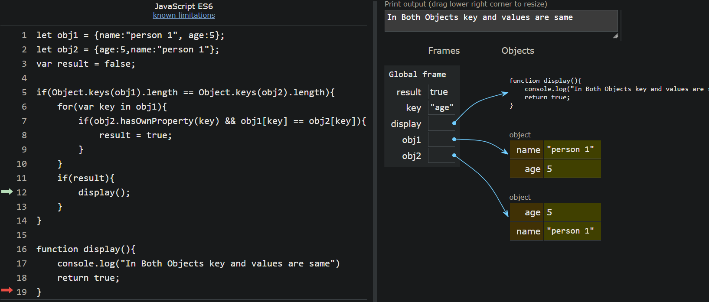

**2) using rest API to show flags in console?**

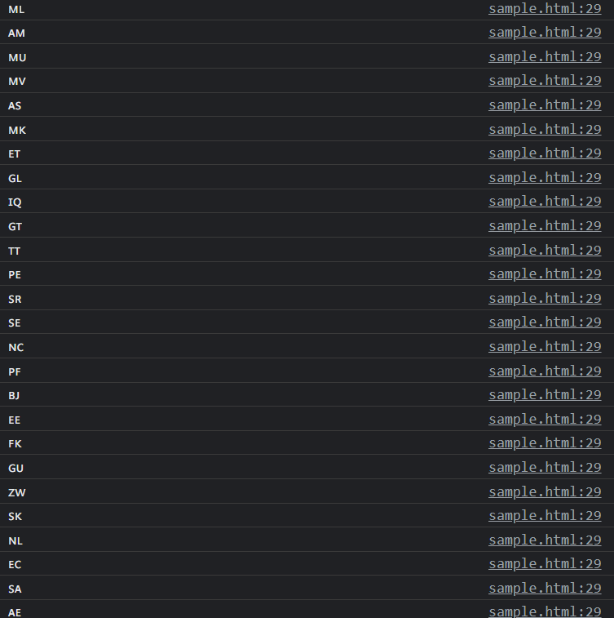**based on browser version and type it will be differing flag name or flag image in output**

**3) show country name, region, sub region and language using rest URL?**

**Output:**

